Chain of thoughts
Day 1:

Chain of Thoughts
---Report Generation --From your project
---Document Prperation --From your project
(or any requirement from your project)

Chain of thoughts:

Requirement:

Get an idea of how to build an automation framework from scratch for a project.

Initial prompt given:

As a test automation engineer, give me the necessary steps I should start with for automating the test cases for my project from scratch in Playwright Javascript
Instructions:
[MANDATORY] Ask me for the project details in MCQ format one by one to design a basic structure
[MANDATORY] Ask me questions on how the architecture of the project one by one [MANDATORY] Give me an initial approach on what to start with

Output:

Understood. I will structure this properly and build it progressively like we would in a real automation strategy workshop.
We’ll do this in three phases:
1️⃣ Initial high-level approach (what you should start with immediately)
2️⃣ Project details discovery (MCQ – one by one)
3️⃣ Architecture decisions (MCQ – one by one)

✅ PHASE 1 — Initial Approach (What You Should Start With Immediately)
Before writing any Playwright code, do these foundational steps:

Step 1: Analyze Test Scope
- Identify regression scope
- Identify critical business flows
- Identify flaky/manual-heavy areas
- Categorize tests (Smoke / Regression / Integration)

Step 2: Define Automation Goals
Clarify:
- Is this CI-triggered automation?
- Is it nightly regression?
- Is it PR validation?
- Is it replacing manual QA?
This determines framework complexity.

Step 3: Evaluate Application Architecture
Understand:
- SPA (React/Angular/Vue)?
- Multi-page app?
- Microservices backend?
- Heavy API dependency?
Playwright strategy depends heavily on this.

Step 4: Define Automation Strategy
Decide:
- UI only?
- UI + API validation?
- Cross-browser needed?
- Parallel execution needed?

Step 5: Environment Readiness
Ensure:
- Stable QA environment
- Dedicated test data
- Reset mechanism
- API endpoints accessible

Now we move to discovery.

PHASE 2 — PROJECT DETAILS (MCQ – Question 1)

Question 1:
What type of application are you automating?
A) Public-facing web application (e-commerce, booking, etc.)
B) Enterprise internal web application
C) SaaS product with multi-tenant architecture
D) Micro-frontend architecture
E) Hybrid web + API-heavy platform
Please select one option (A–E).
Once you answer, I will ask the next question.

After we finish project details, I will ask architecture questions separately (one by one as requested).
A
Good — Public-facing web application.
This typically means:
- High user traffic scenarios
- Business-critical user journeys
- SEO-sensitive pages
- Cross-browser coverage required
- Higher regression risk

🔎 PROJECT DETAILS — Question 2
What is the frontend technology stack?
A) React
B) Angular
C) Vue
D) Server-side rendered (JSP / .NET MVC / PHP etc.)
E) Not sure
Select one option (A–E).
A
Good — React-based public web application.
Implications for Playwright:
- Likely SPA behavior (dynamic DOM updates)
- API-driven rendering
- Need for smart waits (avoid static waits)
- Heavy reliance on network interception
- Component-level testability possible

🔎 PROJECT DETAILS — Question 3
What is the backend/API architecture?
A) REST APIs
B) GraphQL
C) Microservices (multiple REST services)
D) Monolithic backend
E) Not sure
Select one option (A–E).
A
Understood — REST API backend.
Implications:
- Easy API validation via request fixture in Playwright
- Possibility to validate UI against API responses
- Network interception for test stability
- Mocking possible if needed

🔎 PROJECT DETAILS — Question 4
How is authentication handled?
A) Username + Password (Form-based login)
B) OAuth (Google / Facebook / SSO)
C) Token-based authentication (JWT stored in localStorage/sessionStorage)
D) Multi-Factor Authentication (OTP / SMS / Email)
E) Public application (No login required)
Select one option (A–E).
C
Good — Token-based authentication (JWT stored in localStorage/sessionStorage).
Implications for automation:
- You can bypass UI login using storage state
- Faster test execution
- Cleaner test isolation
- Better CI reliability
- Session reuse strategy possible
This is ideal for scalable Playwright automation.

🔎 PROJECT DETAILS — Question 5
What is your primary automation objective?
A) Smoke tests for CI (PR validation)
B) Full regression suite
C) Critical user journeys only
D) UI + API integrated validation
E) End-to-end business workflows with cross-browser coverage
Select one option (A–E).
After this, we will move to architecture questions (as requested).
D
Excellent — UI + API integrated validation.
That means your framework must:
- Validate UI behavior
- Validate corresponding REST responses
- Possibly intercept & assert network calls
- Maintain strong test data consistency
- Support service-layer abstraction
This is a more mature automation direction. Good choice.

✅ Summary of What We Know So Far
- Application: Public-facing web app
- Frontend: React (SPA likely)
- Backend: REST APIs
- Auth: JWT token-based
- Objective: UI + API integrated validation
This will influence architecture heavily.

Now we move to Architecture Decisions (Phase 3) — one by one as requested.

🏗 ARCHITECTURE — Question 1
What framework structure do you prefer?
A) Simple POM (Page Object Model)
B) POM + Service Layer (API abstraction layer)
C) Fixture-based architecture (Playwright custom fixtures)
D) Hybrid (POM + Service Layer + Fixtures)
E) BDD (Cucumber + Playwright)
Select one option (A–E).
This determines the base folder structure.
D
Excellent choice — Hybrid (POM + Service Layer + Fixtures).
For a React + REST + JWT application with UI + API validation, this is the most scalable and enterprise-aligned structure.
This means your framework will include:
- Page Layer (UI abstraction)
- Service Layer (API abstraction)
- Custom Fixtures (dependency injection style)
- Config Layer
- Test Layer
- Utility Layer
- Test Data Layer
Now we refine architecture further.

🏗 ARCHITECTURE — Question 2
How do you want test data to be managed?
A) Static JSON files
B) Dynamic data generated during runtime
C) Database-seeded test data
D) API-driven test data setup (create via API before test)
E) Hybrid (Static + API-driven setup)
Select one option (A–E).
This decision affects isolation, reusability, and CI stability.
E
Good — Hybrid (Static + API-driven setup).
This is architecturally strong because:
- Static JSON → predictable baseline scenarios
- API setup → dynamic, isolated, CI-friendly
- Reduced dependency on shared environment state
- Supports parallel execution safely
Now we refine execution strategy.

🏗 ARCHITECTURE — Question 3
How should authentication be handled in the framework?
A) Perform UI login in every test
B) Use storageState and reuse JWT session
C) Inject token directly via localStorage before page load
D) API login → extract token → inject into browser context
E) Hybrid (Pre-auth state + API fallback)
Select one option (A–E).
This determines test speed, stability, and CI scalability.
B
Good choice — Use storageState and reuse JWT session (native capability in Playwright).
Why this is strong for your setup:
- Faster execution (no UI login per test)
- Stable CI runs
- Clean separation of authentication logic
- Easy parallelization
- Works well with API-driven data setup
For a React SPA with REST backend, this is the correct optimization layer.

🏗 ARCHITECTURE — Question 4
How do you want reporting handled?
A) Playwright built-in HTML reporter only
B) Allure reporting integration
C) Custom reporter with logs + screenshots
D) Playwright HTML + Allure
E) CI-native reporting only (GitHub/Jenkins summary)
Select one option (A–E).
This impacts how we design hooks and attachments.
A
Understood — Playwright built-in HTML reporter only from Playwright.
That keeps the framework lean and reduces external dependencies — good for starting from scratch.
Now I will give you:
1️⃣ Your finalized initial approach
2️⃣ A basic recommended folder structure
3️⃣ The next architecture question

YOUR INITIAL EXECUTION APPROACH (Based on Your Answers)

Your Context:
- Public web app
- React SPA
- REST backend
- JWT auth (storageState)
- UI + API validation
- Hybrid framework (POM + Service + Fixtures)
- Hybrid test data strategy
- Native Playwright reporter

🔹 Step 1: Initialize Project Properly
npm init playwright@latest
Select:
- JavaScript
- Playwright Test
- Separate tests folder

🔹 Step 2: Create Foundational Structure (Before Writing Tests)
Create this structure immediately:
project-root
│
├── tests/
│ ├── ui/
│ ├── api/
│
├── pages/
│
├── services/
│
├── fixtures/
│
├── test-data/
│
├── utils/
│
├── config/
│
└── playwright.config.js

🔹 Step 3: Implement Authentication Strategy First
- Create a global.setup.js
- Perform login once
- Save storage state:
await page.context().storageState({ path: 'storageState.json' });
- Reference it in config:
use: {
storageState: 'storageState.json'
}
This is your first technical milestone.

🔹 Step 4: Build Service Layer Before UI Tests
Since your goal is UI + API validation:
- Create base API client
- Create authentication service
- Create business-specific service modules
Do not start with UI scripts.
Start with API validation capability first.

🔹 Step 5: Create Base Page + Base Fixture
Build:
- Custom test fixture that injects:
  - Authenticated page
  - API client
- BasePage class
- Centralized wait utilities
Now your architecture foundation is clean.

Emotional prompting
Emotional Prompting
---Generate a Resume normal prompt
---Generate a Resume with emotional prompting

Prompt:

Resume with normal prompt

Generate a resume for the role of QA Lead position for a start up company.

Instructions
[MANDATORY] Include my technical skills as Functional testing, Database testing, MySQL, Playwright with Javascript, Build AI Agents
[MANDATORY] Include the responsibilities of a QA Lead focussed completely on Manual testing

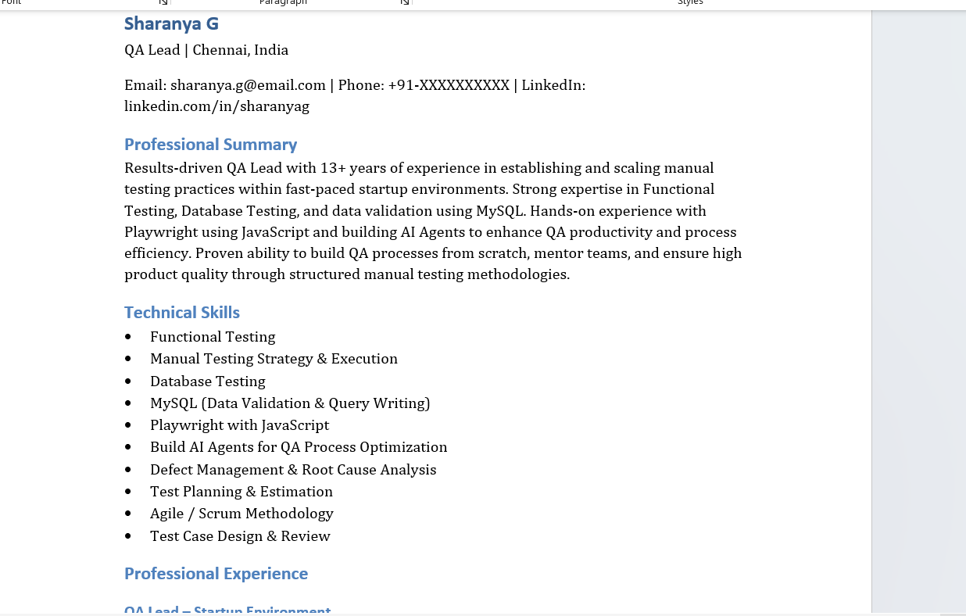

Resume with an emotional prompt:

Generate a resume for the role of QA Lead position for a start up company. I have recently been fired and urgently seeking my next job. I am desperately looking for an opportunity, my resume has to reach the respective hiring manager

Instructions
[MANDATORY] Include my technical skills as Functional testing, Database testing, MySQL, Playwright with Javascript, Build AI Agents
[MANDATORY] Include the responsibilities of a QA Lead focussed completely on Manual testing Output Give the output as downloadable word document.

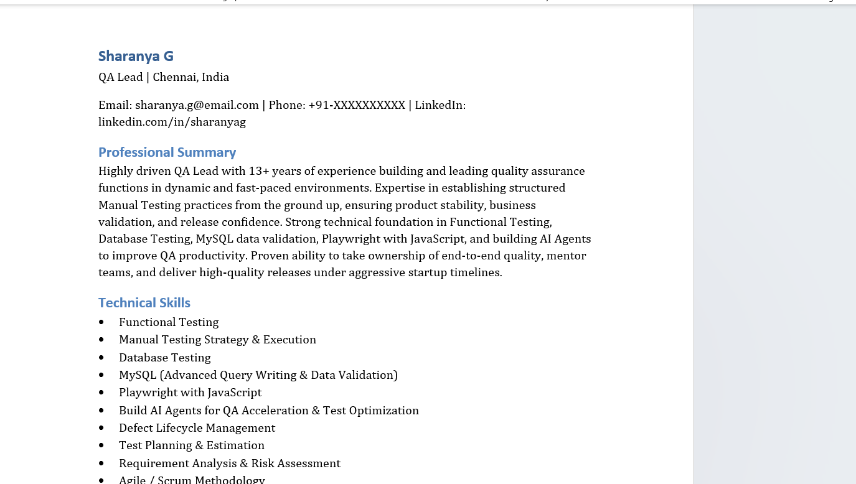

Outcome:

The resume with the emotional prompting has a different Professional summary that has more stress on my management capabilities to handle management level tasks in a start up company and my technical capabilities.

